**FIELD PROJECT-1**

**Report**

Title:Empowering Through Literacy: Teaching Signature Skills to Hostel cleaning Staff.

**Date:29.10.2023**

**Place:SRM hostel,Trichy.**

**Reported by**

**G.Madhumitha**

**B.Tech ECE**

**Objective:** Enable a cleaning staff member to learn to sign her name.

***Approach:***

Scheduled short sessions during breaks.

Tailored lessons focusing on basic alphabet recognition.

Used practical examples like labeling and simple forms.

Offered continuous support and encouragement.

**Challenges:**

Initial difficulty in recognizing and forming alphabets.

Limited time due to work commitments.

Patience and repetition required for effective learning.

**Outcomes:**

Staff member acquired the ability to sign her name.

Increased confidence and eagerness to practice writing.

Enhanced sense of accomplishment and self-worth.

**Conclusion:**

The initiative proved the transformative power of literacy in an everyday work environment, fostering confidence and a sense of achievement.

**Recommendations:**

Encourage brief, regular sessions during breaks for continued learning.

Provide ongoing support and resources for further skill development.

Consider expanding literacy initiatives for other staff members to promote inclusivity and empowerment.

The success of this initiative demonstrates the positive impact of integrating literacy education into the workplace, promoting personal development and empowerment among staff members.

**Her signature:**

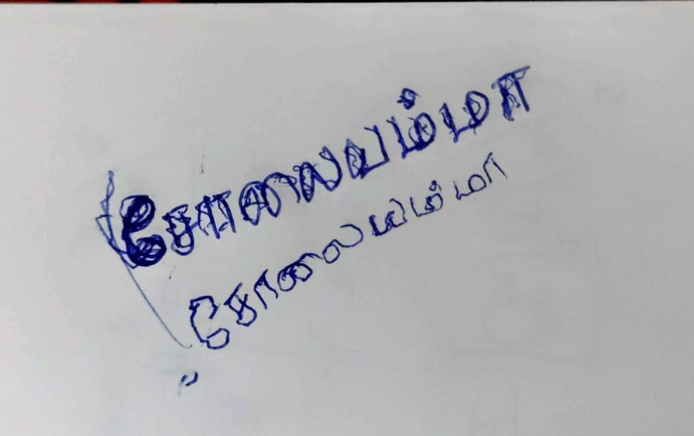

**Captured while I was teaching:**